SPAAMFAA Board of Trustees Meeting
REGULAR MEETING
Wednesday, July 17, 2019
Radisson Hotel
Jeffersonville, IN

Minutes
Voting members in attendance –
Frank Tremel President
Steve Heaver Sr. Vice President
David Napier Vice President
Ron Driscoll District #1 Trustee
Jim Kurycki District #2 Trustee
Jim Derstine District #3 Trustee
Tim “Cosgrove” Jones District #4 Trustee
Howard Peiffer District #5 Trustee (Proxy for Mike Healy)
Warren Lun District #6 Trustee
Roger Birchfield District #7 Trustee
Chuck Buschardt District #8 Trustee
Kent Cullom District #9 Trustee
William Blunden Executive Secretary

Non-voting members in attendance -
Ted Elder Immediate Past President/ Endowment Committee
Scott Rollins Editor, Enjine! Enjine!
Candy Bennett Membership Secretary
Leroy Wilder Treasurer
Jim Debbie Davis Archives Committee Chair
David Lewis Website Committee Chair
Anthony Buono Attorney (Pro Bono)
Dan Lintz Preservation Award Chair

The meeting was called to order by President Frank Tremel at 9:13 am. The pledge of allegiance followed.
Jeff Rider, from the PPSI, our hosts welcomed the group to Indiana and gave a quick overview of the happenings.
Steve Heaver asked everyone to stand while he read off the names of the deceased members who have passed in 2019.

Minutes of the previous meeting in Charleston were emailed previously to the Trustees. There were no additions or corrections to the minutes and they were approved on a motion by Tim Jones, seconded by Steve Heaver, and carried with 12 in favor and one abstained.

OFFICER REPORTS:
- David Napier reported that Warren Lun had indeed submitted his report to him but was misplaced. This will be corrected in the report.

- Tim Jones reiterated that the Trustees should get an email list from Candy Bennett of all the members in their area so that they can keep members who may not be members of a local chapter informed of what is happening in SPAAMFAA. There are a number of national members who do not belong to local chapters.

- Roger Birchfield reported that Wisconsin was in District #7 not District #6. This has been corrected and Candy Bennett has updated the SPAAMFAA Chapters by Region chart. Warren Lun reported that there were no actual breakdowns in communication with the chapter as he was communicating with them regularly.

- Chuck Buschardt is working with the chapters in his district that have not submitted their annual reports, Insurance information, Safety rules and membership lists. Discussion on how to handle chapters that have not submitted the required information was moved the New Business later in the meeting.

- Leroy Wilder updated his report to reflect the finances to date. He discussed that the PayPal account is being moved from Wells Fargo to PNC bank. He is working with Len Williams to make the necessary changes as Len was the last contact on record. He is in the process of looking at all of our accounts to make sure they are up-to-date with signatures and contacts.

- Leroy reported that he is using QuickBooks and has never used this program before. He may be investigating other software options to use in the future that will better serve the needs of the society. There was a discussion on Restricted -v- Non-Restricted funds. There were two anonymous donations that he placed in the Restricted Funds. He would like to have a separate line item for this type of transaction. Steve Heaver stated that this is possible with QuickBooks and will share an example of what he does at the Maryland Fire Museum to accomplish this.

- Leroy was thanked for his work taking over the job as treasurer. Steve Heaver then publicly thanked Stan Socha for the hard work he did as the treasurer straightening out our finances.

- There are two bills from Modern-Litho that are due and at this time there are no other outstanding bills.

- Tim Jones asked about the $5,000-line item under theft loss in the financial report. Leroy was not sure what this was as it happened prior to his taking over. President Tremel discussed the issue with the board. On 2/27/19, money was taken from an account that is not normally used by the society. Stan became aware of this and an investigation was conducted. It was determined that Bill Dundas withdrew the money from the account after he had been expelled from the society to pay the attorney, he had hired without board approval. It was determined that this withdrawal should be reported as a theft loss according to our insurance company. It was also determined that Mr. Dundas had signed a contract with the attorney group and there was now an outstanding bill for more than $14,000. Chuck Buschardt asked about the board’s responsibility for this bill. Anthony Buono discussed the legal issues with this. He was later notified that the attorney group would be willing to settle for $10,000 if we paid immediately. In reviewing the bill, Anthony stated that many of the charges were exorbitant and that he has sent a letter to the attorney stating that we would not be paying anything. This occurred in April and there has been no further correspondence from them. It is assumed for the time being that there will be no further action taken by them.

- There was a discussion about who may have been involved in this matter other than Mr. Dundas. Chuck Buschardt reported that he had had discussions with Bill Killen who refused to answer questions on the advice of “our” attorney which makes it appear that he may have had some involvement in the hiring of the attorney. We are awaiting information from the Charleston police department as they have stated they have letters indicating there may have been other(s) involved with this. Chuck then asked how this could have happened as he had been expelled and was told to have nothing to do with the organization. A letter was sent to the bank informing them that Mr. Dundas was no longer to have access to accounts but that he had been able to withdraw the money before the bank could notify their branches. None of the board members have indicated that they knew that the attorney had been hired and Mr. Dundas refused to answer questions from multiple board members regarding the potential litigation he had mentioned. The Board of Trustees will await information from the police to determine what, if any further action needs to be taken.

- Deb Davis reported that the new archivist is now in place. She has been having regular communications with him and work is getting done. The “jury is still out” as to how he is working out overall.

- Ted Elder discussed the endowment fund. The endowment committee has agreed to fund $3,500 towards the new website design bill. This along with the $4,000 in anonymous donations will cover the cost of the design. This appropriation was approved on a motion by Tim Jones, seconded by Jim Derstine and passed. The decision was unanimous.

- Ted Elder reported for John Zangerle who was unable to attend the meeting due to health issues. The committee met on 7-16-19 to finalize the budget for the year. There is a line item with $50,000 in it for ready cash in the event of an emergency. David Napier suggested that putting some or all of this in a higher yielding account than a CD may be a better option. Discussion was held to put $25,000 in high yield and $25,000 in CD. Ted will discuss this with John Zangerle.

- Candy Bennett discussed the Life Member category and how this is being handled. She reported that there are currently 281 life members, many of whom have been members for many years and we are at the point where we are “losing money” on them. The Board discussed possible actions that could be taken to address this with no final decision being made. Candy suggested that the Trustees try to determine if any of the life members in their districts have died so they can be taken off the list. She noted that one member had died 5 years before she discovered it. We had been sending EE to them the entire 5 years.

- Active membership is at 2,000 members to date with about 450 who have not renewed as of this date.

- David Lewis gave an overview of the new website which could include different levels of membership. We would offer certain things for free, other sections if you give your email address and other areas for members only. There is the potential to do electronic memberships which would drastically cut down on costs/member. Candy Bennett and the committee members were thanked by David Lewis for her help with building the new site.

- President Tremel discussed the process used to select the company designing the website.

- There was discussion about a joint conference with the International Fire Buffs Association in the future. Kent Cullom discussed some of the logistics. The IFBA will be making a presentation later in the day to the board.

- Dan Lintz discussed the Preservation award and how he is trying to re-organize. Discussion held on whether museums should be eligible for the award. This program was designed to be a recruiting tool. A committee will work on re-working this program and then report back to the board.

CORRESPONDENCE:
- The Executive Secretary reported that the insurance premium was due and that our premium was a few dollars higher but our deductible has been raised from $1,000 to $2,500.
- The Executive Secretary will contact Hagerty insurance about the possibility of doing a you-tube video on SPAAMFAA and restoration as a recruitment tool.
- There is a group looking to become a chapter. The information on how to form a chapter was sent but there has been no word back. Candy Bennett will try to determine who the email is from so we can contact them.

Motion To recess for lunch by Jim Derstine and seconded by Tim Jones and carried at 11:40am.

CTO at 12:45 by President Tremel

ELECTIONS: There was a discussion regarding the upcoming elections and concerns that were voiced after the last election. Tim Jones suggested that a private company be hired to conduct the elections but this was deemed to be too expensive. Also discussed having the ballots sent to a neutral 3rd party and this too was rejected. There was a discussion on using different color ballots, envelopes and the possibility of using bar codes to make sure that the elections are fair.
It was decided to continue to do the elections as they have been done with one exception. The ballots will be printed on special security paper to prevent unauthorized ballots from being submitted.
The elections will be run by the executive secretary. The assistant executive secretary or a person designated by the executive secretary will be responsible for the ballot counting and then return the results to the executive secretary to be shared with the board of trustees.

For this upcoming election the three presidents and the trustees for districts 1, 4, and 9 will be on the ballot. There is the potential for another trustee position if the current trustee decides to run for a VP position. There will be a BIO created that will be 1/3 of a page for each candidate.

BY-LAWS: Ted Elder reported that there is a need for a change to the bylaws. When the society switched form 4 regions to 9 districts, there was a section of the bylaws that failed to be changed. The change is to Article III section 11. (See Attachment A) for the specific resolution.
David Napier suggested that sections 11.2 and 11.4 be removed and leave the decision to the members. The board members did not agree to this and the resolution will remain as written. The resolution was approved on a motion by Steve Heaver and seconded by Jim Kurycki. The resolution will be put on the ballot in the upcoming election.

BUDGET: Tim Jones suggested that the actual cost of lifetime members be calculated and then look at possibly using some of the endowment investments to help offset the costs of this group. There was a discussion on the possible uses of the 3% limit on endowment fund use.

It was decided to amend the proposed budget and increase the line item for elections by $250 to $4,250 balancing the budget and to account for the special paper to be used. This then required that the total line out be changed from $6,500 to $6,750. A motion to amend the budget was made by Jim Kurycki and seconded by Tim Jones and carried on a unanimous vote by the trustees. (See Attachment B).

On a motion by Jim Derstine and seconded by Chuck Buschardt, the endowment committee was increased from 5 to 6 members by making the finance committee chairman part of the endowment committee. This motion was carried unanimously.

Treasurer Leroy Wilder continues to go thorough the various accounts to make sure the correct names are on them. One account still had Len Williams name on it. Ted Elder was designated to be a signer on the PNC account in the event that Leroy is unable to sign checks on a motion by Jim Derstine and seconded by Tim Jones and carried unanimously.

GOALS:
There was a discussion regarding the goals for the next 6 months. The need to recruit new members was the major topic of discussion. Chairman Steve Heaver reported that the new member committee (David Lewis, Chuck Buschardt, Bill Blunden, and Paul Schlichting) is actively working on the project. There will be a specific follow-up system in place to ensure new members are contacted. There will be radical changes coming to the process in the near future.
Trustees were encouraged to contact non-renewing members to remind them to renew. There was a long discussion on the need to recruit new members as well as how to deal with older members who do not use electronic communications. Anthony Buono reported that we may want to consider another level of membership, Electronic Membership class. All publications would be sent electronically and they would have access to files electronically. This would significantly decrease our costs and help increase membership of younger people. The committee will review this and report back to the board.
We need to focus on increasing the number of preservation awards, as these help to increase our visibility and potentially increase new member applications. Bill Blunden will see how many applications we currently have available.

BREAK: The board took a break from 15:09 to 15:32

IFBA PRESENTATION: There was a presentation by the International Fire Buff Association President Rick Short and 3 IFBA members (Dennis Ahrens, Dave Williams and Chris Oliphant) on the potential to have a joint summer convention/muster. This has been discussed on and off for years. There are many members who belong to both organizations. It appears that the summer of 2022 may be the first opportunity to do this. Kent Cullom and Brian Anderson Jr. will work with the IFBA on this.

REIMBURSEMENT ISSUE: Mr. Dundas, who had been expelled from the society, had submitted a bill for $13,000 for reimbursement for his expenses as President of SPAAMFAA. These bills go back to 2008 but contained no receipts or other documentation. Leroy Wilder reported that there are at least 10 of these items that had been previously paid. A motion was made by Tim Jones, seconded by Chuck Buschardt and carried unanimously to reject this claim and direct the executive secretary to send Mr. Dundas a letter stating that he would not be paid for these bills.

POLICY CHANGE: On a motion by Jim Derstine and seconded by Jim Kurycki, all bills over $50 must be submitted with receipts and proper documentation within 60 days and those under $50 within 6 months or they will not be paid. The motion was approved on a unanimous vote.

POTENTIAL LEGAL ISSUE:
President Tremel reported that the North Charleston Police have told him that the $5,000 withdrawal by Mr. Dundas after the meeting in February 2019 to pay the attorney is not a criminal matter and is now considered a civil matter. President Tremel is waiting for documentation from the police to determine what other actions are to be taken. It does not make sense to pursue the civil case at this time. There is the potential that there were others involved in this case and the police related they may have documentation to that effect.
Chuck Buschardt asked what the plans are to deal with the bill from the lawyer Mr. Dundas hired in excess of $17,000? Anthony Buono explained that Clifton Mount, from the law firm has been told that we will not be paying anything for this as the board did not know or approve any contract(s) entered into by Mr. Dundas. There have been no further communications from the group since this letter was sent in April 2019.

Chuck Buschardt then asked what can be done to keep Mr. Dundas from re-joining the society. There was along discussion on the matter. The bylaws discuss this but are unclear because there is one section that does not address expelled members specifically. Tim Jones suggested that Mr. Dundas be banned for life from the society.

President Tremel read a letter he had drafted to chapter presidents explaining what had happened regarding the $5,000. Until we get more information and documentation from the North Charleston Police, there is not much we can do. It was decided to table this discussion for the time being to give people time to think about the best course of action. Motion to recess at 17:30 by Jim Derstine and seconded by Jim Kurycki and carried. We will meet again Thursday evening 7/18/19 at 18:15.

REGULAR MEETING CONTINUATION
Thursday, July 18, 2019

The meeting was called to order by President Tremel at 18:21 with all members present with the exception of Warren Lun and Howard Peiffer who were late.

Two items were discussed at this meeting. The first item was to approve the 2020 summer convention bid by the Genesee Chapter. The convention will be in Rochester NY and will be put on by the Genesee, Central NY and Thousand Islands Chapters August 12-15, 2020. The hotel will be the Double Tree Hotel and the muster to be held a Cobb Hill. A motion was made by Chuck Buschardt and seconded by Roger Birchfield to accept this bid and approved unanimously.

*A poll was taken by President Tremel later that day to approve the bid by the Pacific Northwest Chapter to host the summer of 2021 convention. This bid was approved by the board of trustees.

The next order of business was the discussion of the Dundas matter and how this should be addressed to the membership. Executive secretary Bill Blunden read the letter he had drafted to Mr. Dundas rejecting his bill for reimbursement. On a motion by Jim Derstine and seconded by Roger Birchfield and approved unanimously this letter will be sent to Mr. Dundas.

David Napier is concerned that if we address this with the membership, we may be opening a box of problems both with the members and Mr. Dundas. He suggested that we leave things as they are and leave him alone. He stated that Mr. Dundas will not be coming back.

A proposal was read by Anthony Buono changing Article III section 9 clearing up the wording to ensure that expelled members cannot be reinstated for membership in the future. David Napier was concerned about due process but this is not affected by this wording and that this is a housekeeping issue not a person specific issue. President Tremel reminded the board that what is done by man, can be undone by man. In the future, the board can change these bylaws again and eliminate this change.
President Tremel then asked each board member to share their feelings on this. There were many members who were torn about the best thing to do. There is the potential that any further discussions regarding Mr. Dundas may open old wounds and cause continued problems but there is also the potential that members may feel the board is not doing anything about it and sweeping it under the rug”.
There was a motion made by Steve Heaver, seconded by Chuck Buschardt to amend the bylaws by adding the following sentence (Any member expelled from the society shall not be re-admitted) to the existing bylaw Article III section 9. The vote was 5 in favor and 5 opposed. President Tremel cast the deciding tie breaking vote. He voted NO causing the motion to be defeated.
A discussion on how we handle questions that may arise at the membership meeting regarding the unauthorized $5,000 withdrawal by Mr. Dundas. It was decided that due to the lack of specific documentation from the North Charleston Police, we are unable to say anything at this time. The President will address any questions by stating that “On advice of legal counsel, we cannot say anything about this until we have the final report and documentation from the police department.

With no further business, the meeting was adjourned on a motion by Kent Cullom, seconded by Dave Napier and carried at 19:00.

Respectfully Submitted,

William M. Blunden
Executive Secretary

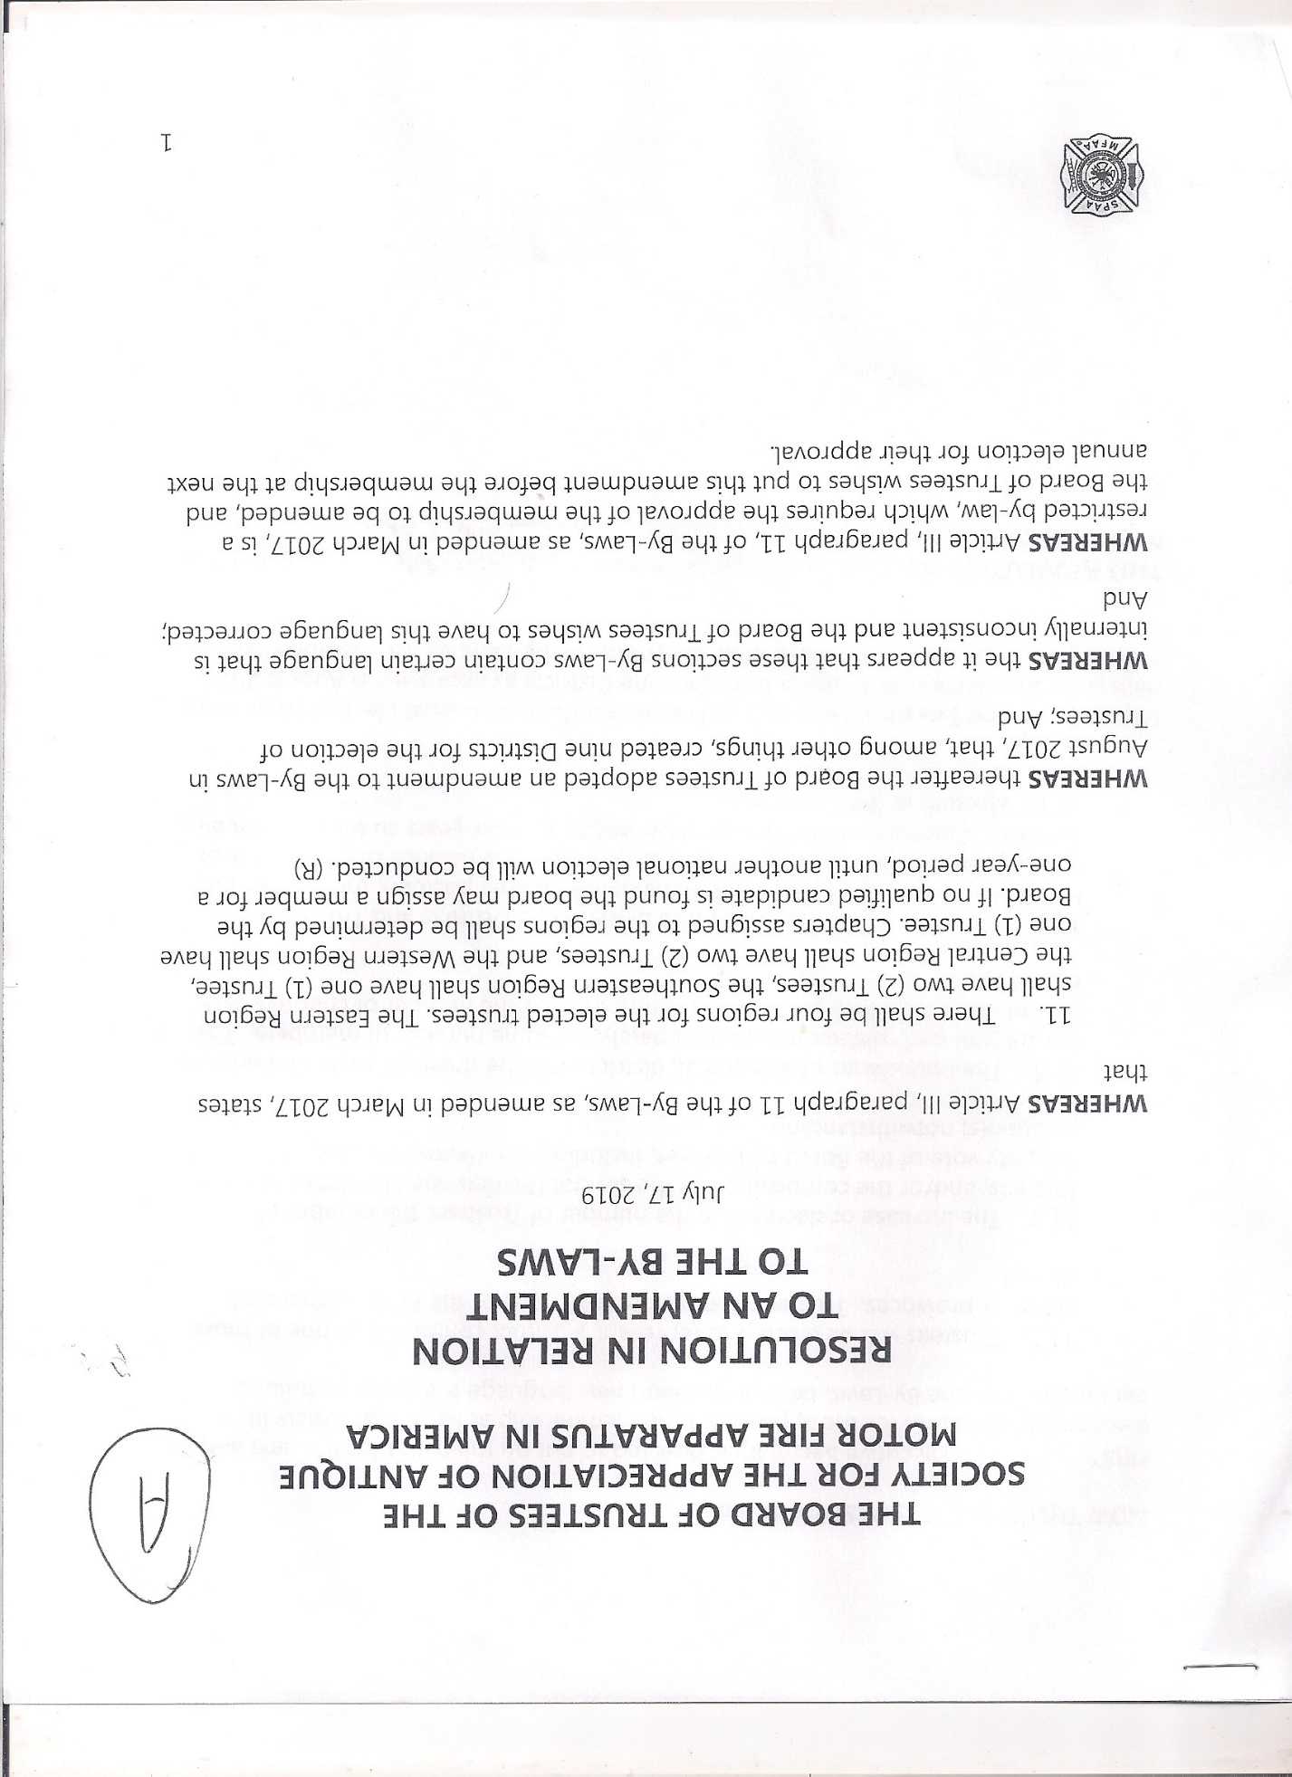
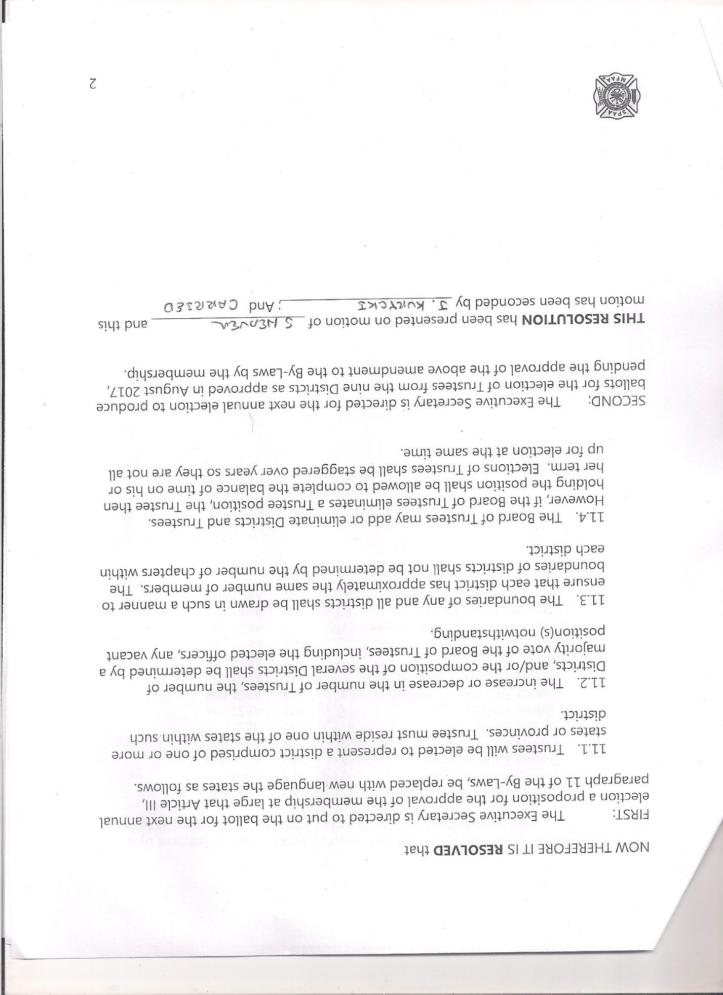
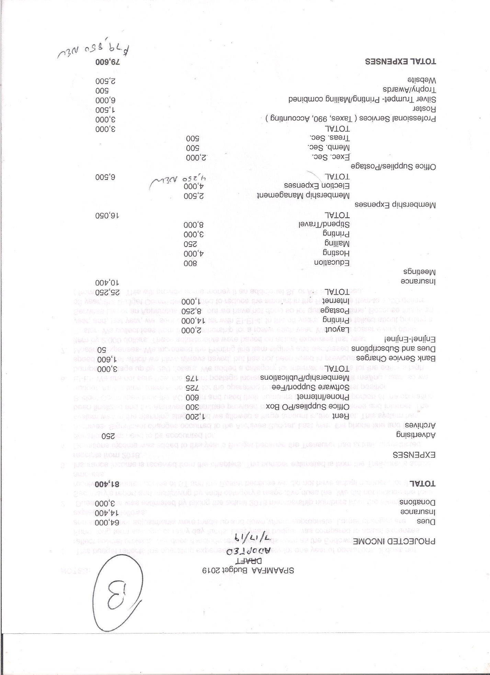
SPAAMFAA Chapter Presidents & Membership Meeting
Friday, July 19, 2019
Radisson Hotel Jeffersonville, IN
Minutes

The meeting was called to order by President Frank Tremel at 7:06 pm. The pledge of allegiance followed. There were 22 chapters represented and approximately 150 members in attendance.
There was a moment of silence as Steve Heaver asked everyone to stand while he read off the names of the deceased members who have passed in 2019.

President Tremel welcomed everyone to the meeting and gave a brief talk about the happenings of the week. He then asked the Chapter Presidents if there were any issues that needed to be brought up. There were no questions asked and the meeting was then opened up for comments by the general membership. The following comments/issues/questions were raised:

- Three members stood and thanked the Board of Trustees for all they have done in the past few months to get the society back on track.
- A member asked what the board was doing to address the aging and declining membership. Steve Heaver and David Lewis discussed how the membership committee and the new website committees are working on this.
- A member suggested the possibility of a combined national/local chapter membership fee. This will be investigated.
- Dan Lintz asked the members to recommend recipients for the preservation award to help attract new members.
- A member asked why we have elections every year, especially for the presidents. It seems like they never have the opportunity to get started and then can be replaced.
- A member asked if the ST and EE are back on track and if moving the submission dates back might help them keep on schedule.
- Jeff Rider asked if something could be done to help new chapters get started. The insurance fee makes it tough to get started when they have to give $300 right off the bat. There are some possibilities that will be investigated.
- A member suggested that there might be an opportunity to have a grant program to assist new chapters get their feet on the ground financially.
- Warren Lun asked people to consider giving to the Soderbeck and endowment funds and that there is the opportunity to claim this on your taxes.
- A member asked "I wonder if we could be enlightened to any degree, about a non-member taking a large amount of funds out of our bank account in South Carolina". President Tremel responded: "All I will say on that, and I' being serious. On advice of legal consul, I'm not going to say anything at this time". There was no further discussion.
- David Lewis gave a quick overview of the new website and some of the features.
The meeting was Adjourned at 7:55pm.

Respectfully Submitted:

William Blunden, Executive Secretary

